Talia Ricketts
Period 6/7
May 22nd, 2015

Mouse Swim Lab Report
Question/Purpose: Will the male or female mice memorize the location of the platform faster?
Hypothesis: If 12 mice are tested for their ability to remember a hidden platform in a Morris swim maze‚ then the females will memorize the platform location faster than the male mice.
Materials: 2 Kiddie pools, 12 mice, hose, powdered milk, water, 2 coffee cans w/lid, stopwatch, rocks, notebook data table, writing implement, mouse cages, towels, laptop, measuring cup, sharpie.
Procedure:
- Fill kiddie pools almost full with of water.
- Put in 1 cup powdered milk and stir to dissolve.
- Add coffee can full of rocks as an underwater platform in center of pool.
- Get timer ready.
- Place one mouse in the pool.
- Time mouse swimming and stop when mouse finds platform.
- After 120 seconds, if mouse has not found platform put mouse on platform for 10 seconds.
- Remove mouse and dry with a towels. Replace mouse in cage after 60 seconds.
- Re-mark albino mouse tails.

Date | 1 | 2 | 3 | 4 | 5 | 6 | 7 | 8 | 9 | 10 | 11 | 12
4/21/15 | 74 | 120 | 45 | 120 | 9 | 120 | 120 | 120 | 67 | 20 | 6 | 79
4/21/15 | 6 | 120 | 120 | 120 | 35 | 40 | 20 | 49 | 37 | 120 | 32 | 120
4/22/15 | 120 | 120 | 120 | 13 | 87 | 120 | 39 | 77 | 39 | 45 | 120 | 39
4/22/15 | 74 | 86 | 16 | 2 | 41 | 82 | 6 | 72 | 28 | 120 | 47 | 6
4/22/15 | 6 | 17 | 120 | 35 | 120 | 22 | 13 | 46 | 18 | 120 | 43 | 29
4/22/15 | 4 | 120 | 120 | 119 | 60 | 33 | 24 | 59 | 7 | 5 | 38 | 3
4/24/15 | 8 | 29 | 120 | 9 | 105 | 113 | 33 | 1 | 99 | 20 | 9 | 11
4/24/15 | 97 | 120 | 120 | 120 | 13 | 55 | 42 | 23 | 10 | 45 | 14 | 35
4/27/15 | 5 | 39 | 44 | 30 | 15 | 6 | 82 | 120 | 47 | 77 | 4 | 3
4/29/15 | 2 | 17 | 11 | 120 | 15 | 4 | 3 | 16 | 19 | 6 | 118 | 43
4/29/15 | 6 | 18 | 120 | 30 | 4 | 15 | 120 | 102 | 17 | 16 | 120 | 47
4/29/15 | 25 | 61 | 120 | 20 | 40 | 5 | 27 | 117 | 20 | 20 | 24 | 12
5/1/15 | 3 | 20 | 3 | 29 | 57 | 10 | 27 | 113 | 10 | 34 | 24 | 120
5/1/15 | 7 | 15 | 1 | 21 | 4 | 18 | 28 | 15 | 23 | 120 | 54 | 120
5/4/15 | 51 | 120 | 11 | 120 | 9 | 47 | 3 | 60 | 18 | 38 | 2 | 120
5/4/15 | 120 | 39 | 4 | 41 | 18 | 2 | 51 | 24 | 30 | 45 | 120 | 9
5/4/15 | 2 | 14 | 9 | 112 | 119 | 13 | 3 | 8 | 54 | 18 | 4 | 7
5/4/15 | 1 | 16 | 50 | 39 | 120 | 3 | 3 | 32 | 4 | 11 | 65 | 3
average | 34 | 61 | 64 | 61 | 48 | 39 | 36 | 59 | 30 | 49 | 47 | 45
Group Avg. |  | 51 |  |  |  |  |  | 44

Conclusion: The hypothesis stated that the female mice would memorize the platform location faster than the male mice. The hypothesis not supported by the data. The average swim time for the females was fifty five seconds, compared the male whose average swim time was forty four seconds, this lead to the hypothesis not being supported by the data. Sources of error that affected the data were that the pool was leaking water. Some groups might’ve been very loud, which could’ve taken away the mouse’s focus. Another source of error was that the mice might’ve not been faced towards the field every single time, which could’ve confused them.

Recommendations: To fix these sources of error you can replace the pool leaking with water. You can also remind the groups to please be quiet. Last you can have a mark where you are supposed to place the mouse (red tape) so that it is very clear. Put the pool as to the tape is facing the field with a black arrow also marked onto it.
Application: A scientist would be the person to most likely want this information to see whether males or females can recognize the same situation, over a course of time, better.

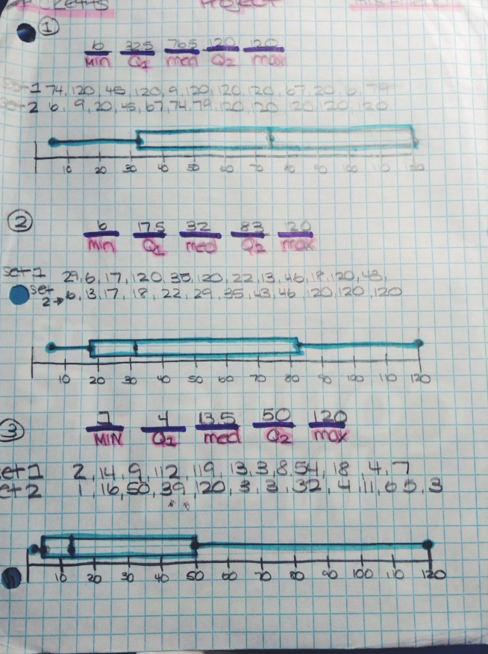
In the first box-and-whisker plot it shows that the median is about 75, the longest time is one hundred twenty seconds, and the shortest time is six seconds. In the second box-and-whisker plot that the median is around thirty, the longest time is one hundred twenty seconds, and the shortest time is six seconds again. The third box-and-whisker plot has a median of almost fifth teen. The longest time is one hundred and twenty seconds, while the shortest time length is one second. As you take a look on all of the graphs, time after time, the median starts to become a lower number. This goes to show that the mice seem to be able to locate the platform faster. It also goes to show that the mice are starting to memorize where the platform is. The maximum time is always one hundred twenty.

