Explorations Through Time - Life Has a History
http://www.ucmp.berkeley.edu/education/explotime.html - Go to "Life Has a History" ' Level 2
1. How many different species of living things exist today? ___________________
2. Which group of animals has the largest number of species? _______________________
3. How many mammal species exist today? ______________
4. Number the organisms from 1 (most abundant) to 8 (least abundant)
____ Mammals ____ Molluscs___ Roundworms ____ Arthropods ____ Flatworms
5. What is biodiversity (click on the purple links for definitions): _______________________________
6. 470 Million Years Ago (click circle for a "closer look" at the period)
What was the name of the period? ________________________
What was the dominant predator? ____________________________
What was the first arthropod? ________________________
7. 160 Million Years Ago
What was the name of the period? _____________________________
What large marine reptile existed? _____________________________
8. How old is the earth? _______________________
9. Fill in the blanks of the timeline
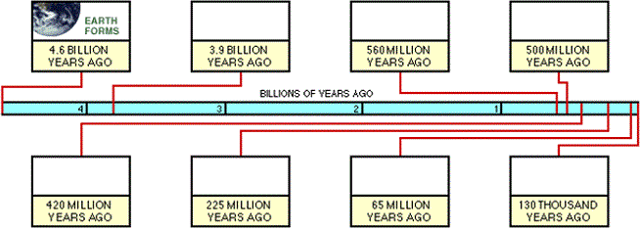
10. The best source of evidence for determining events in earth's history is ______________
11. What is a paleontologist? __________________________
12. Identify three fossils from the image. Name them and point to them with an arrow

13. What features are found in therapods? _____________________________________
14. What is a cladogram? ________________________________________
15. What is divergence? _____________________________________
16. To which animal are the crane and eagle most closely related? _______________________
17. What other data (besides physical features) do scientists use to find if organisms are related? List 3 things. _______________________________________
18. What birds on the Galapagos islands were adapted to different regions? ________________
19. The beaks of the birds vary with what? ___________________________________
20. What would happen if the environment changed and only plants with larger, harder seeds survived.How do you think that might affect the population of Geospiza fortis finches? _____________________________________
21. What is geographic isolation? _____________________________________________
22. Identify the extinct creature. _________________________________________
23. Name two animals that have gone extinct since humans have been present? ________________________

