**2015  
ST. LUCIE COUNTY FAIR**

**4-H PREMIUM BOOK**

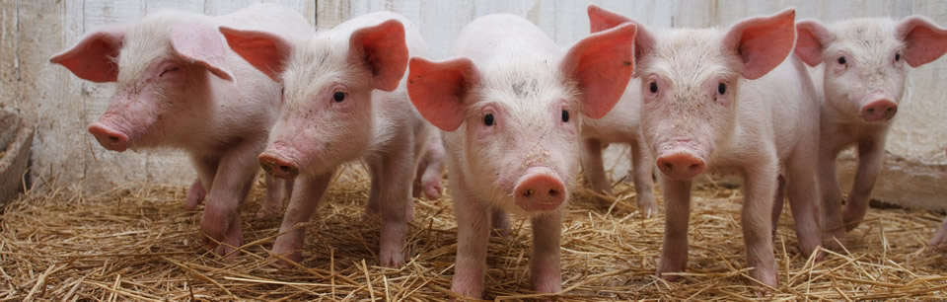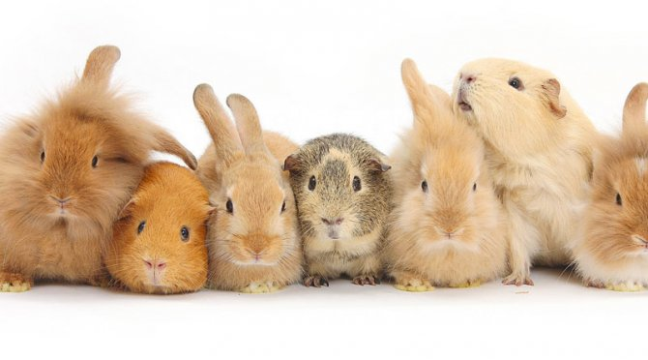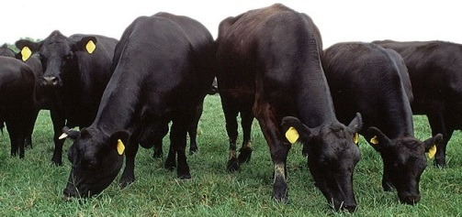

**FEBRUARY 27TH - MARCH 8TH**

**Learn By Doing**

ST. LUCIE COUNTY COOPERATIVE EXTENSION SERVICE

County Extension Director

Horticulture Extension Agent Anita Neal

4-H/Agriculture Extension Agent Sue Munyan

Natural Resources Extension Agent Ken Gioeli

Citrus Extension Agent Parker Platts

Family Consumer Science Agent Karla Lenfesty

Commercial Horticulture Agent Ed Skvarch

Extension Program Coordinator Kate O’Neill

Office Assistant Ana Cerda

4-H Program Specialists Debbie McManus

Carley Miranda











The Institute of Food and Agricultural Sciences **IFAS** is an Equal Employment Opportunity- Affirmative Action Employer authorized to provide research, educational information and other services only to individuals and institutions that function without regard to race, color, sex, age, handicap or national origin. **U.S. DEPARTMENT OF AGRICULTURE, COOPERATIVE EXTENSION SERVICE, UNIVERSITY OF FLORIDA, IFAS, FLORIDA A.M. UNIVERSITY COOPERATIVE EXTENSION PROGRAM, AND BOARDS OF COUNTY COMMISSIONERS COOPERATING.**

Funding for the duplication of this publication is provided in part by the St. Lucie County Board of County Commissioners

**4-H SCHEDULE**

|  |  |  |  |  |
| --- | --- | --- | --- | --- |
| **DAY**  Wed.  Thurs  Wed | **DATE**  Jan 7  Jan 15  Jan 28 | **TIME**  7:00pm  6:30 pm  7:00 pm | **ACTIVITY**  Beef Breeding Mandatory Meeting  (*if showing a heifer/bull at the fair*)  Small Animal Barn Mandatory Meeting  Horse Barn Mandatory Meeting  (*If showing/housing a horse at the fair)* | **PLACE**  Fairground  Hurricane House  Fairgrounds |
|  |  |  |  |  |
|  |  |  |  |  |
|  |  |  |  |  |
|  |  |  |  |  |
|  |  |  |  |  |
|  |  |  |  |  |
|  |  |  |  |  |
| Mon. | Jan 19 | 10am -12pm | Dog Show Clinic | Fairgrounds |
|  |  |  |  |  |
|  |  |  |  |  |
|  |
| Fri  Sat. & Sun  . | Feb 6  Feb 14 & 15 | By 4 pm  10am - 2pm | Horse Barn Record Books due  Enter Photography  *(for fair exhibit)* | 4-H Office  Fair Building |
| Tues | Feb 10 | 10am - 2pm  4:00 pm | Enter Art Exhibits  *(for fair exhibit)*  Enter Home Arts Bldg  Small Animal Record Books Due | Fair Building  Fair Building  4-H office |
|  |  |  |  |  |
| **Sat**  ***NEW*** | **Feb 14** | **10am-2pm** | **4-H Exhibits Due** | **Fairgrounds Bldg A** |
|  |  |  |  |  |
|  |  |  |  |  |
| TBA |  | TBA | Small Animal Barn Set Up  (MANDATORY) | Fairgrounds |
|  |  |  |  |  |
|  |  |  |  |  |
| Thurs. | Feb 26 | 10am - 5pm | Vegetable & Horticulture  Exhibits Entered | Fairgrounds Bldg A |
|  |  | 5pm - 7pm | Small Animals Enter | Barn Area |
|  |  | 5pm - 7pm | Beef Breeding Enter | Barn Area |
|  |  |  |  |  |
|  |  |  |  |  |
| Fri. | Feb 27 | **FAIR OPENS** |  |  |
|  |  | 7am - 10am | Swine Enter | Barn Area |
|  |  | By Noon | Horses Enter | Barn Area |
|  |  | 3pm - 10pm | Exhibits Displayed | 4-H Booth |
|  |  | 6:30pm | Beef Breeding Show | Livestock Arena |
|  |  |  |  |  |
|  |  |  |  |  |
| Sat. | Feb 28 | 8am-noon | Small Animal Show | Small Animal Barn |
|  |  | 12:30pm | Jr. Beef Show | Livestock Arena |
|  |  | 4:00pm | Swine Show | Livestock Arena |
|  |  | 9:00pm | Beef Breeding must be out after |  |
|  |  |  |  |  |
|  |  |  |  |  |
| Sun. | Mar 1 | 7am - 9am  9:00 am  Noon –2pm | Steers Enter  Horse Show  Horticulture Identification Contest | Barn Area  Adams Arena  Home Arts Bldg. |
|  |  | 5:00pm | Swine Sale | Livestock Arena |
|  |  |  |  |  |
|  |  |  |  |  |
| Mon. | Mar 2 | 4pm - 5pm  6:00pm | Cakes, Pies & Candy Entered  Judging | Home Arts Bldg A  Home Arts Bldg A |
|  |  | 6:00pm | Swine Showmanship & Grooming | Livestock Arena |
|  |  |  |  |  |
|  |  |  |  |  |
| Tues. | Mar 3 | 7:00pm | Steer Show | Livestock Arena |
|  |  |  |  |  |
|  |  |  |  |  |
| Wed. | Mar 4 | 4pm - 5pm  6:00pm | Bread, Cookies & Canned Items Entered  Judging | Home Arts Bldg A  Home Arts Bldg A |
|  |  | 7:00pm | Steer Sale | Livestock Arena |
|  |  |  |  |  |
|  |  |  |  |  |
| Thurs. | Mar 5 | 6:30pm | Steer Showmanship & Grooming | Livestock Arena |
|  |  |  |  |  |
|  |  |  |  |  |
|  |  |  |  |  |
| Fri. | Mar 6 | 4:30pm  6:00 pm | Beef & Swine Exhibitor Awards  Dog Show | Livestock Arena  Livestock Arena |
|  |  |  |  |  |
|  |  |  |  |  |
| Sat. | Mar 7 | 1:00 pm | 4-H Pee Wee Pig Show | Livestock Arena |
|  |  |  |  |  |
|  |  |  |  |  |
| Sun. | Mar 8 | Noon | Small Animal & Horse Awards | Livestock Arena |

GENERAL RULES & REGULATIONS

For 4-H Exhibits

1. Open to all St. Lucie County 4-H members enrolled by September 1, 2014

2. NEW!! Each member is allowed a maximum of 3 entries per category. Exhibits must be made by the exhibitor since the last Fair. Categories include: photography, art, ceramics, sewing, woodworking, 4-H poster art, animal science, robotics, horticulture, Legos, environment, science and technology, recreation, general. The 4-H staff reserves the right to create more categories as necessary.

3. NEW!! All exhibits will be entered into the 4-H Booth located at the Fairgrounds Bldg A on Sat February 14th between 10am-2pm. **No 3 fold Science Fair boards allowed**. **Exhibits will not be accepted at the 4-H Office unless SPECIAL arrangements are made prior to Sat Feb 14th.**

4. Exhibits are entered at owner's risk. Every precaution will be taken to protect exhibits, but St. Lucie County 4-H will not be responsible for loss or damage.

5. Food exhibits must be brought to the Women's World exhibit area on Monday, March 2nd from 4:00pm - 5:00pm and Wednesday, March 4th from 4:00pm - 5:00pm. All entries must be accompanied by the recipe. **ITEMS REQUIRING REFRIGERATION WILL NOT BE ACCEPTED.**

6. Premiums will be awarded in the following events: Project Exhibits, Vegetables, Horticulture and Food Exhibits.

Rosette-$15.00 Blue-$10.00 Red-$8.00

7. All exhibits will be judged by qualified persons and decisions of the judges will be final.

8. Blue, Red and White ribbons will be awarded to each exhibit by the judges according to its merit. Rosettes will be awarded to outstanding exhibits in each category.

9. When designated, “Clover Bud” is defined as a member’s age 5-7 years of age as of Sept. 1, 2014,"Junior" is defined as member’s ages 8 to 10 years of age as of Sept. 1, 2014. "Intermediate" is defined as member’s ages 11 to 13 years of age as of Sept. 1, 2014. "Senior" is defined as member’s ages 14-18 years of age as of Sept. 1, 2014.

POSTER ART CONTEST

1. NEW!! All exhibits will be entered into the 4-H Booth located at the Fairgrounds Bldg A on Sat February 14th between 10am-2pm.

2. Top three (3) posters selected at County will be exhibited at District and enter the State Contest.

3. Those three (3) County winners selected for the State Contest will receive art pins. Three (3) State winners will receive plaques and be sent to the National 4-H Council for exhibit during National 4-H Congress.

4. On back of poster (upper left hand corner): name, age, full address, and a brief statement explaining the artwork.

5. Size 14x22 inch (standard poster board.) Only horizontal or vertical posters are acceptable.

6. Theme may be:

a. 4-H Makes a Difference

b. "Open" create a theme and poster to go with it. Avoid "Join 4-H",

3-dimensional and copyrighted materials.

c. "It’s a Green Thing"

d. "Learn by Doing"

1. 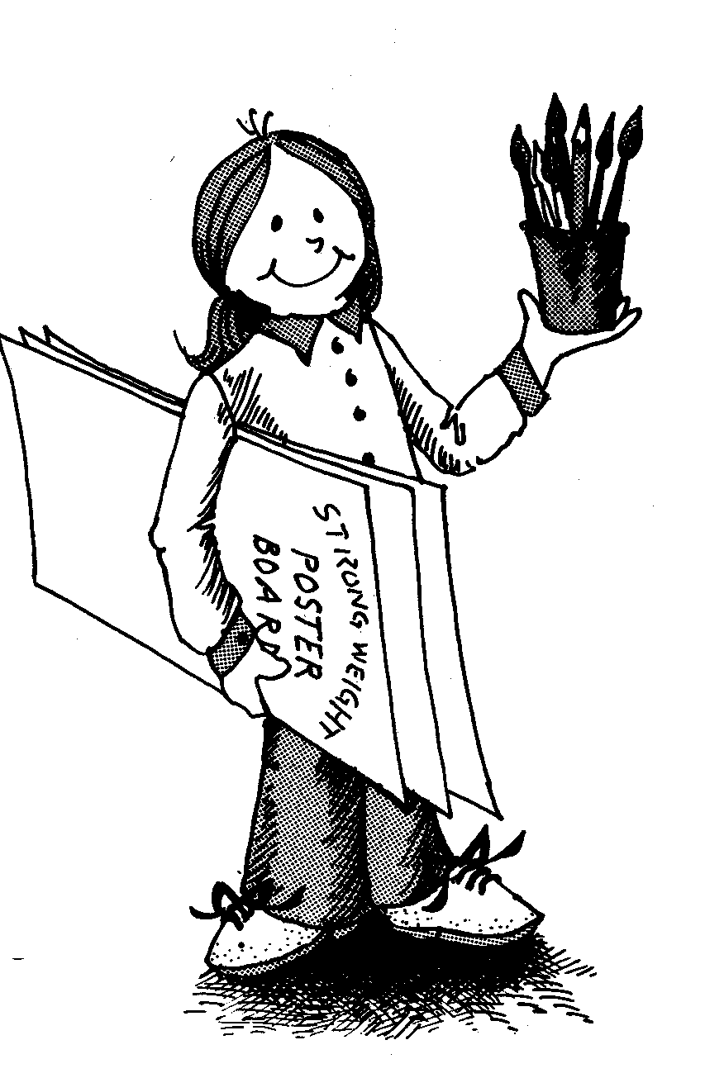Any art medium is acceptable (water color, ink, crayon, acrylic, charcoal, oils, collage)

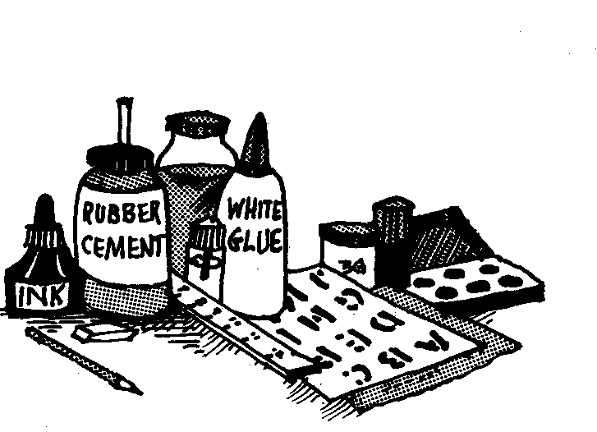









4-H ART SHOW

CLOVER BUD-5-7, JUINOR- 8-10, INTERMEDIATE- 11-13, SENIOR- 14-18

1. NEW!! All exhibits will be entered into the 4-H Booth located at the Fairgrounds Bldg A on Sat February 14th between 10am-2pm.

1. All exhibits must be the work of the exhibitor and not previously exhibited in the Fair Show.
2. No entry may be removed until Monday, March 9, 2015.
3. Ribbons and prizes will be awarded by qualified judges. Decision of judges is final.

MCEN00505_0000[1]To enter a fair exhibit in addition to the 4-H booth exhibit, see the HOMEARTS premium book

www.stluciecountyfair.org

4-H PHOTOGRAPHY SHOW

CLOVER BUD-5-7 , JUINOR- 8-10, INTERMEDIATE- 11-13, SENIOR- 14-18

1. NEW!! All exhibits will be entered into the 4-H Booth located at the Fairgrounds Bldg A on Sat February 14th between 10am-2pm.
2. Each exhibitor is allowed **a total of 3** photography entries into the 4-H photography
3. All exhibits must be the work of the exhibitor.
4. No entry may be removed until Monday, March 9, 2015.
5. Size of photo not to exceed 11x14" and must be properly framed and wired
6. Ribbons and prizes will be awarded by qualified judges. Decision of judges is final.
7. On back of exhibit attach card with name, age, address and a short identifying caption.
8. Blue, Red and White ribbons and rosettes will be awarded.
9. Four (4) winners may exhibit at District Events and enter State Contest. (Top four (4) State winners exhibit at National).

**To enter a fair exhibit in addition to the 4-H booth exhibit see the HOMEARTS premium book for rules**

[**www.stluciecountyfair.org**](http://www.stluciecountyfair.org)

* **All pictures must have wire hangers attached to the back of frame**
* **No more than a total of 3 entries per person**

 ****

Bar Hook (Saw Tooth)

Wire **Preferred Method**

**Not Allowed**



Item must fit on this peg board hook

4-H and FFA All Breed Youth Dog Show

Date: Friday, March 6th, 2015

Time: 6:00 p.m.

Place: Livestock Arena St. Lucie County Fair Grounds

Participants are encouraged to attend a Dog Show Clinic on Monday, January 19, 2015 from 10:00 a.m. to noon at the Fairgrounds in the Livestock arena. Learn how to show your dog, so you can practice before the fair dog show.

You must pre-register for the dog show by February 13, 2015. Registration forms and class list will be available at the January 19th clinic or at the 4-H office.

MCj02812240000[1]

FOOD EXHIBITS

1. Any member enrolled in Foods and Nutrition project.

2. Bring to Home Arts Building on Monday, March 2rd, 4:00 pm - 5:00pm for Cakes, Pies and Candy; Wednesday, March 4th 4:00pm - 5:00pm for Breads, Cookies, & Canned Items, judging at 6pm.

3. 1 item per category each day.

4. Recipe used must be submitted. (Recipes from project books preferred)

5. Use a non-returnable container, covered with clear plastic.

6. Items that require refrigeration will not be accepted.

7. Bring a complete unit. (Whole recipe or at least 8 servings)

8. After foods are judged, a portion will be displayed and the remainder will be sold to the public and all money used for the Home Arts Bldg.

* Check Fair website for details: [www.stluciecountyfair.org](http://www.stluciecountyfair.org)

**Horticulture Plant ID**

**Contest**

1. Any member may enter
2. Contest is Sunday March 1, 2015 in Bldg A starting at 12 Noon
3. Pre register for the contest by Mon Feb 16, 2015 by emailing Sue Munyan [sjmunyan@ufl.edu](mailto:sjmunyan@ufl.edu)
4. Ribbons and Premium money for each participant
5. Contest plants will be selected from the Horticulture Plant Identification List 2014-15

**COUNTY EVENTS**

**DEMONSTRATIONS**

TIME: Monday, March 23, 2015

Time 6:00pm

PLACE: St. Lucie County Extension Office – Hurricane House

Registration due: Tuesday, March 17, 2015

1. Demonstrations should be an outgrowth of the member's 4-H project or activity.

2. Topic must pertain to the 4-H project in which the member is currently enrolled.

3. No live animals may be used.

4. Demonstration must have been given first at club level.

5. Must provide all equipment and supplies needed for presentation.

6. Length: Sr (Age 14-18): 5 to 12 minutes

Int (Age 11-13): 3 to 12 minutes

Jr (Age 8-10): 3 to 12 minutes

7. One (1) Blue Ribbon Junior, one (1) Blue Ribbon Intermediate and one (1) Blue Ribbon Senior in each category will go to District Events.

To be eligible to attend 4-H University in July, 4-H’ers (14-18) must participate in County Events.

**4-H FASHION REVUE**

DATE: Monday, March 23, 2015

TIME: 6:00pm

PLACE: St. Lucie County Extension Office

1. Participants must be enrolled in the Clothing Project.

2. Participants must submit description of garment and information about themselves by Tuesday, March 18, 2014.

3. Awards: ribbons

# SHARE-THE-FUN TALENT CONTEST

Will be held with County Events on Monday, March 23, 2015 at the St. Lucie County Ext.

Time: 6:00pm

The following rules will apply:

1. Any member may enter.

2. Individual or group entries are acceptable.

3. In case of group entries, all members must be in the same age classification (Jr., Int. or Sr.) in order to go on District Events.

4. Groups are limited to five members.

5. Each act is allowed between 3 and 5 minutes.

6. A stage and a microphone will be provided. All acts must supply their own musical and sound equipment.

7. The top two (2) senior, top two (2) intermediate and top two (2) junior acts will be eligible for District Events.

8. Scoring: Talent 30%

Showmanship 35%

Costume & Staging 35%

TOTAL 100%

4-H Pledge

I pledge my Head to clearer thinking,

My Heart to greater loyalty, my Hands to larger service, and

My Health to better living,

for my club, my community, my country, and my world.

4-H Motto

To Make the Best Better

